


VU
Verteiltes Programmieren
mit
Space Based Computing
Middleware
Complang
TU Wien

Task 2

Implementation of a forum

System Architecture

Author: Michael Greifeneder
Version: 1.0

Use Cases Diagram

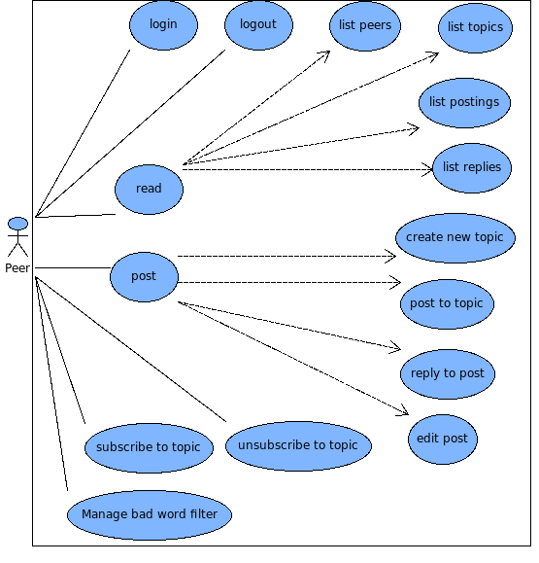

Neutral interface description
Each implementation (XVSM and RMI) must implement a hierachy of interfaces. These interfaces are used by a graphical user interface to get information about and make changes to the forum.

Description of interfaces
SessionFactory: Implementations of this class are the solely classes which have to to instanciated by the user. We offer XVSMSessionFactory and RmiSesssionFactory.
Session: Allows to add a listener and to get a list of peers and the local peer representative.
Peer: Allows to get a list of topics, the name and to create a new topic at the local peer.
Topic: Allows to get a list of postings, to add a posting and subscribe/unsubscribe to topics.
Posting: Allows to get a list of replies, to add a reply and to edit content. Addionally to read properties of a postings like author, subject, content and creation date.
Listener: This interface has to be implemented by the GUI to get notifications about changes.

Implementation Overview for XVSM

List of Containers
A SuperPeer has 2 containers: PeerContainer and TopicContainer. URLs are valid connection strings.
PeerContainer has tuples with 2 entries: url and name. Both have type String. Url is a unique identifier for a peer. Name is a free text.
TopicContainer has tuples with 2 entries: url and topic. Both have type Strings. Url is a unique identifier for a peer and topic a unique name for a topic within a peer.

A Peer has a container PostContainer. Entries in this container has this layout:
(topic:String, parent:Integer, id:Integer, author:String, subject:String, content:String, date:GregorianCalendar)
Replies have a property parent set to id of parent, which is null at postings directly to a topic.

Description of use cases

Use Cases
login | Peer connects to SuperPeer and writes an entry to PeerContainer with his url and his name. Additionally the peer registers a notification to this container and TopicContainer.
logout | Peer connects to SuperPeer and removes its entry and unregisters its notifications for both containers.
read | This use case contains 4 sub use cases: list peers, list topics, list posts, list replies
list peers | Peer connects to SuperPeer and fetches all entries in PeerContainer
list topcis | Peer connects to SuperPeer and selects all entries in TopicContainer where url equals a url of a specific peerl.
list posts | Peer connects to selected peer and fetches all entries in PostContainer where topic matches selected topic and property parent is null
list replies | Peer connects to selected peer and fetches all entries in PostContainer where property parent matches selected post.
post | This use case contains 4 sub use cases: create new topic, post to topic, reply to post, edit post.
create new topic | Peer connects to SuperPeer and writes an entry to TopicContainer with his url and name of new topic.
post to topic | Peer connects to peer of selected topic and writes an entry to PostContainer with property topic set to selected topic, parent set to null and id set to highest id in container incremented by 1.
reply to post | Peer connects to peer of selected post and writes an entry to PostContainer with property parent set to id of selected post and id set to highest id in container incremented by 1.
edit post | Peer connects to peer of selected post and updates entry with property id matches selected post.
subscribe to topic | Peer connects to peer of selected topic and add a notification for entriess with property topic matches selected topic.
unsubscribe to topic | Peer connects to peer of selected topic and removes notification.
manage bad words filter | [TODO]

Implementation Overview for RMI

Each peer runs an RMI server and has an exported interface RemotePeer. The SuperPeer also runs an RMI server and exports interface RemoteSuperPeer.

RemoteSuperPeer
def login(url:String, name:String);
def peers():List[PeerInfo];
def logout(url:String);
def topics():List[TopicInfo];
def newTopic(url:String, name:String);

RemotePeer
def getPostings(name:String):List[PostingInfo];
def getPost(id:Integer):PostingInfo;
def getReplies(id:Integer):List[PostingInfo];
def post(topic:String, parent:Integer, author:String, subject:String, content:String ):Integer;
def edit(id:Integer, content:String);
def subscribe(topic:String, url:String);
def unsubscribe(topic:String, url:String);
//Notifications
def postCreated(url:String, topic:String, id:Integer);
def postEdited(url:String, topic:String, id:Integer);
def peerLoggedIn(url:String, name:String);
def peerLoggedOut(url:String, name:String);
def peerHasNewTopic(url:String, name:String);
}

The classes PeerInfo, TopicInfo and PostingInfo are transfer objects. The classes starting with „Rmi“ are implementing the neutral interface defintions.

Description of use cases
Use Cases
login | Peer connects to SuperPeer and calls method login(). SuperPeer calls method peerLoggedIn() at already logged in peers.
logout | Peer connects to SuperPeer and calls method logout(). SuperPeer calls method peerLoggedOut() at all other peers.
read | This use case contains 4 sub use cases: list peers, list topics, list posts, list replies
list peers | Peer connects to SuperPeer and calls method peers()
list topcis | Peer connects to selected peer and calls method topics()
list posts | Peer connects to selected peer and calls method getPostings()
list replies | Peer connects to selected peer and calls method getReplies()
post | This use case contains 4 sub use cases: create new topic, post to topic, reply to post, edit post.
create new topic | Peer connects to SuperPeer and calls methode newTopic(). SuperPeer connects to all peers and calls peerHasNewTopic()
post to topic | Peer connects to hosting peer of topic and calls method post(). Paramter parent is null. Hosting peer connects to all subscribed peers and calls postCreated()
reply to post | Peer connects to hosting peer of selected post and calls method post(). Parameter parent is set to id of selected post. Hosting peer conects to all subscribed peers and calls postCreated()
edit post | Peer connects to hosting peer of selected post and calls method edit().  Hosting peer connects to all subscribed peers and calls postEdited()
subscribe to topic | Peer connects to hosting peer of selected topic and calls method subscribe()
unsubscribe to topic | Peer connects to hosting peer of selected topic and calls method unsubscribe()
manage bad words filter | [TODO]

